Mentor Registration Instructions
Step 1: Click on the link below to access the Faculty Mentorship Resource Center
https://ufmedmentor.chronus.com/
Step 2: Click the “Join Now” button under the Peer-to-peer program track.

Step 3: Click on the “Mentor” button.
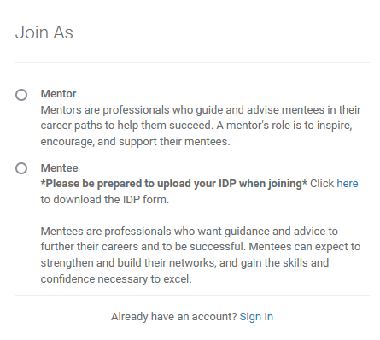

Step 4: Click on “SAML Login” and register with your gatorlink account.
Note: If registering using a personal email, a confirmation email link will be sent prior to registering.
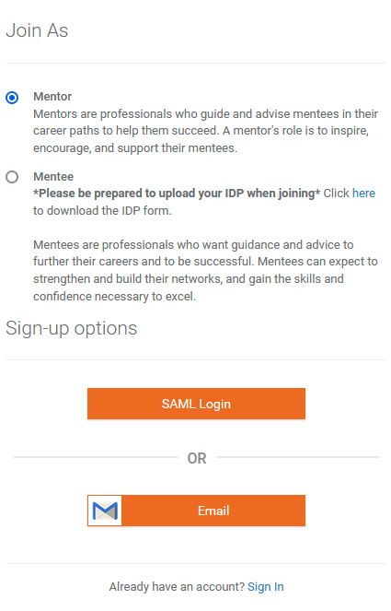
Step 5: Complete the required and optional registration sections and submit
*If you have any questions and/or issues with registering, please click “Contact Administrator” at the top of the webpage.

